ICIN BANK

SPECIFICATION DOCUMENT

JAVIER LUQUE

POST GRADE FULL STACK DEVELOPMENT
IMPLEMENT OOPS USING JAVA WITH DATA STRUCTURES
COHORT 1
2022
Table of Contents
Problem Background 3
Developer Details 3
Project Details 3
jluqueco/LockedMe 4
Sprints 4
Algorithms 4
Application Flow 5
Core Concepts 6
GitHub Tracking 6
Conclusion 7

Problem Background
ICIN is one of the top banking firms that accepts deposits from the public for the purpose of lending loans to the public. It also invests an amount in securities.
Recently, the business analysts noticed a drop in the number of customers of the bank. They found out that online banking systems of banks like AXIS and American Express are gaining more profits by eliminating middlemen from the equation. As a result, the team decided to hire a Full Stack developer who can develop an online banking web application with a rich and user-friendly interface.
You are hired as one of the Full Stack Java developers and have been asked to develop the web application. The management team has provided you the requirements and their business model so that you can easily arrange different components of the application.

Developer Details
Javier Luque will be the developer of this demo representing jluqueco; he is currently a junior Java developer with little experience but eager to learn and to show what he has learned up to this point.

He will be also the project manager and will be in charge of the planning, monitoring and execution of this demo.

Project Details
This project will be divided into two springs (details on the sprint execution document). Estimation were based in hours per day. Third week is planned for changes requested by the user after the demo has been displayed.
All the documentation for this project could be found in the following Github repo:

https://github.com/jluqueco/ICINBank.git

This project was built under two folders:

Back-End– Where all the back-end was developed. This development was done in Java and backed up by a MySQL Database.

Frond-End – This folder contains all the resources needed for the user interface to run, This interface was developed in Angular.

Test cases were designed and run in Selenium.

Sprints
As stated before, Four sprints were planned for this project, each sprint were planned and executed by the developer team. Also, all Scrum activities were executed for this project as documented on the Github repo.

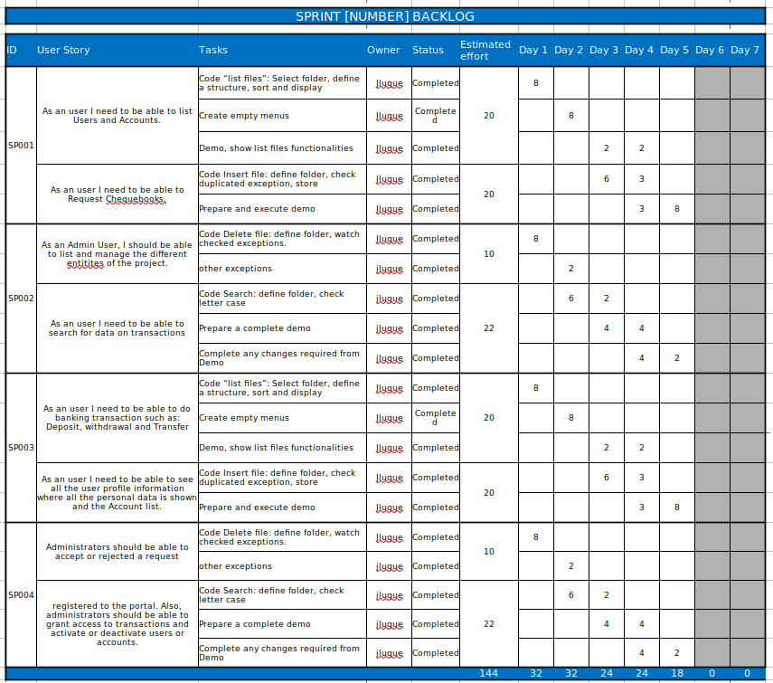

Database Diagram
This app was created under four important entities which were: users, accounts, transactions and chequebooks.

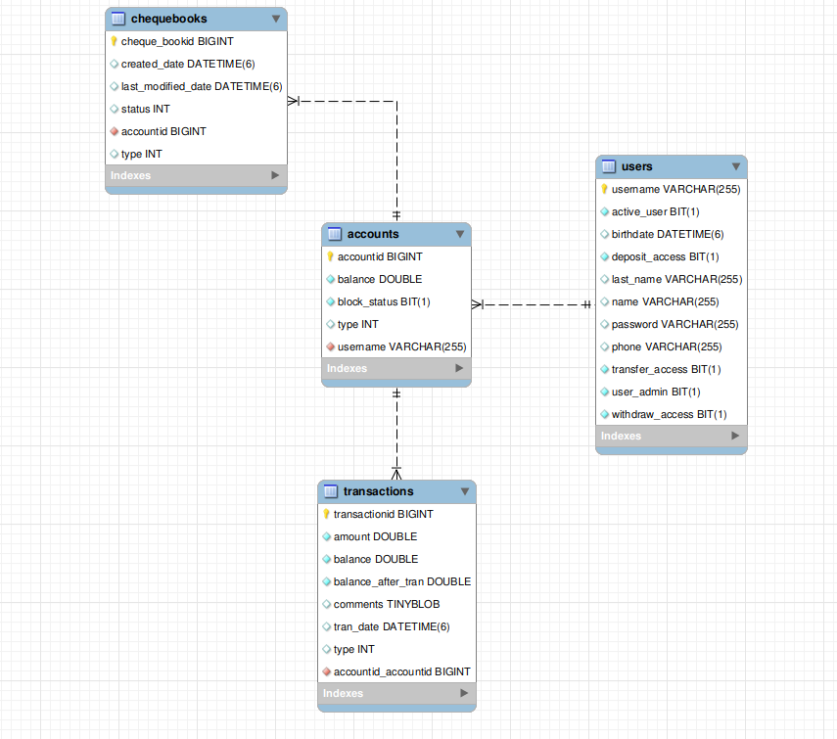

This project could have been developed with a more robust Database design, for example, creating table for admin users only, storing password in encrypted fields on isolated tables, history logs and so on. But due to the nature of the exercise and with the objective of the task which was learning, these details have been simplified.

GitHub Tracking

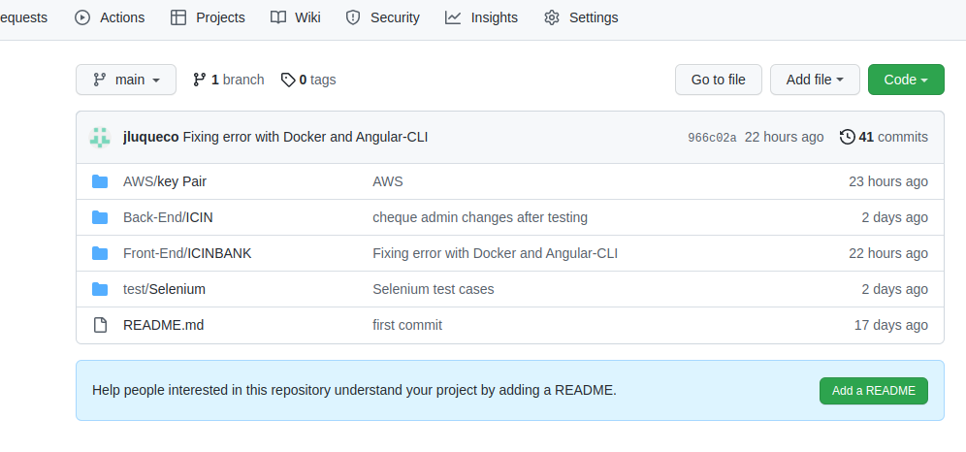
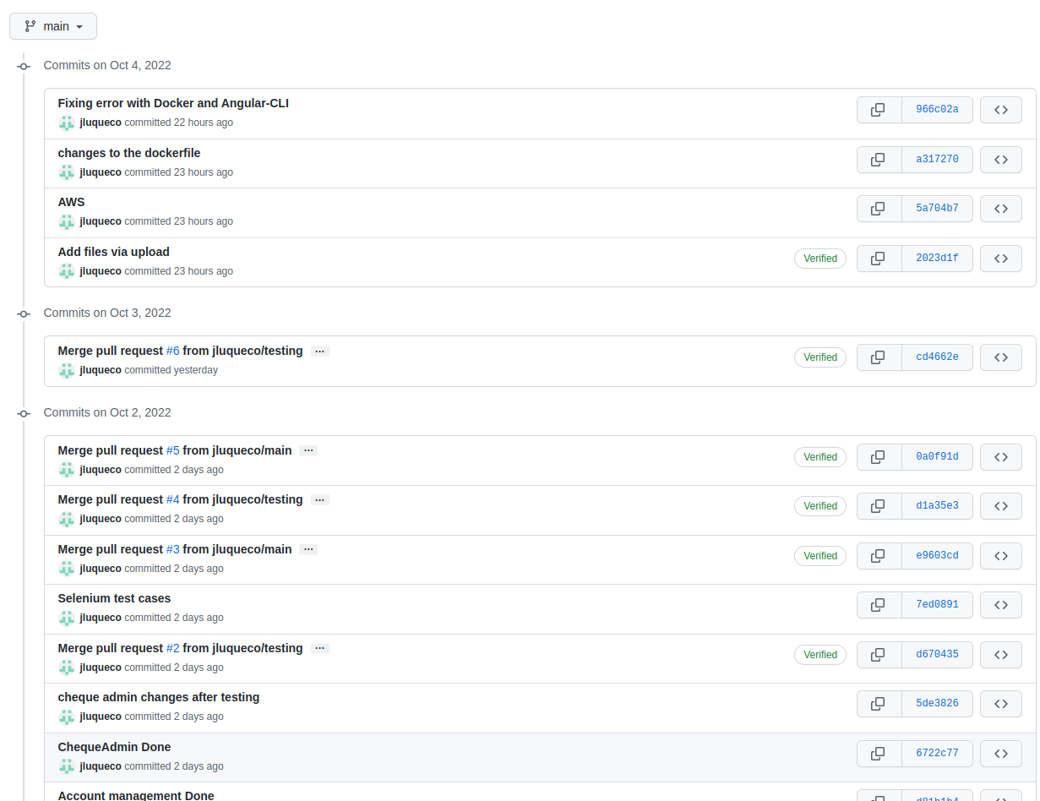

Conclusion
This application was a great challenged, it pushed me to learn and use concepts that were taught during the whole path of this course. Making this project work was fun, challenging and satisfying experience.

